Big Data Project -- Bank Marketing Campaign

Yiheng Wu

Abstract. When I first looked at the database, I found it different and enjoyable. It is not only a real-life situation I can analyze but also a good chance for me to combine information I have learned in school with new information I learned through machine learning and form a path to the result. There are phrases I did not understand or have not even heard of but conquering them through and finishing four major machine models is beyond another level of achievement for me. I made lots of illustrations including graphs and tables to better represent how machine learning functions and how results are achieved.

Keywords: Bank, Machine Learning, Marketing
JEL Codes: H, M
- Introduction
The power of finance has long been inspirational to me. Understanding the usage and scope of money has been proven essential to this modern-day world. We, as customers, or as vendors, need to use money or other currency forms to transact benefits. Based on this public will, banks emerged in early history, along with other simple rules on saving and using money. Later, financial services such as deposits and loans emerged. According to the Oxford Dictionary, the modern explanation for the word “deposit” is “a sum of money placed or kept in a bank account, usually to gain interest”, whereas “loan” means anything that is borrowed and is typically expected to be paid back with interest. Moreover, starting as early as Medieval Ages in Great Britain, depositing valuables in banks was considered the safest way to save goods; time has passed and finally the Bank of Britain’s new identity as the “lender of last resort” was acknowledged. The Bank of Britain not only guarantees the identity of every commercial bank in the UK but also allows anyone to borrow and save money in the bank. (Pettinger, n.d.)

Inflation is a general rise in the price of goods and services over some time. It can be affected in different ways through policies introduced by the government, economic programs launched by a tycoon, or the financial habits people become accustomed to. In general, inflation causes money to lose value. Thereby, if the consumer price index rises, we would realize that our money has devalued. When we look at the inflation rate in recent years, shown in figure 1, it is between 1%~3%. In order not to lose money, we turned to promotions offered by financial institutions. Usually, banks offer a higher rate of return for investments than simply saving money in our accounts, allowing us to maintain the growth in our financial value by beating inflation. A loan is the opposite of a deposit, it means a special form of debt lent by a corporation. (Kagan, 2020)

Typically, banks attract customers by having a higher interest rate than the traditional liquid saving but still lower than the inflation rate. One way to achieve that is by offering a time/term deposit account which is a type of deposit account held by the bank where the money is locked up for some set period, ranging from one month to a few years. Different from a deposit, a term deposit generally means a fixed investment in the form of deposits and cannot be taken out before the term ends. By investigating the deposits and loans a person obtains, we can greatly understand the distribution of wealth in terms of gender, occupation, and other factors. It is exciting for me to investigate how other factors, including the results from past contacts and days between marketing campaigns, influence the acceptance of term deposits among customers contacted.

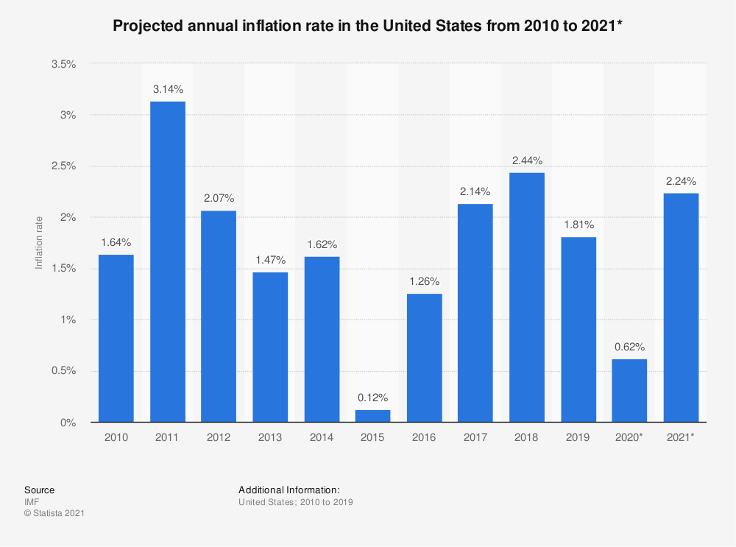
Figure 1. Projected annual inflation rate in the U.S. from 2010 to 2021 (Statista Research Department)

- Research Elaboration
  - Data
I have done some research and found this tremendous dataset I adopted from a Portuguese banking institution under UC Irvine Machine Learning Repository. It has 16 predictor variables, as shown in table 1, and one outcome variable which is whether the client subscribed to the term deposit.

Table 1. A list of variables in the dataset
Variable | Data type | Description
age | numeric | Age of the client
job | categorical | Type of job
marital | categorical | Marital status
education | categorical | Education level
default | binary | Has credit in default?
balance | numeric | Average yearly balance, in euros
housing | binary | Has a housing loan?
loan | binary | Has a personal loan?
contact | categorical | Contact communication type
day | numeric | Last contact day of the month
month | categorical | Last contact month of the year
duration | numeric | Last contact duration, in seconds
campaign | numeric | Number of contacts performed during this campaign and for this client
pdays | numeric | Number of days that passed by after the client was last contacted from a previous campaign
previous | numeric | Number of contacts performed before this campaign and for this client
poutcome | categorical | The outcome of the previous marketing campaign
Output variable | Data type | Description
y | binary | Has the client subscribed to a term deposit?

  - Exploratory Data analysis
To explore the data, A bar plot of the outcome variable with the counts of observations in each categorical bin is shown in figure 2. It shows that the dataset is unbalanced with about 89% of the outcome being “no” and 11% being “yes”. This can be addressed with various techniques during the machine learning phase. Figure 3 is a heatmap of the correlation matrix for numerical variables in the dataset. The color of the squares in the plot represents the magnitude of the correlation coefficient. No specific relationship had been found between different groups.
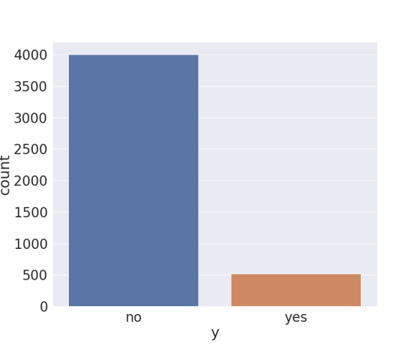
Figure 2. Countplot of the outcome variable “y”
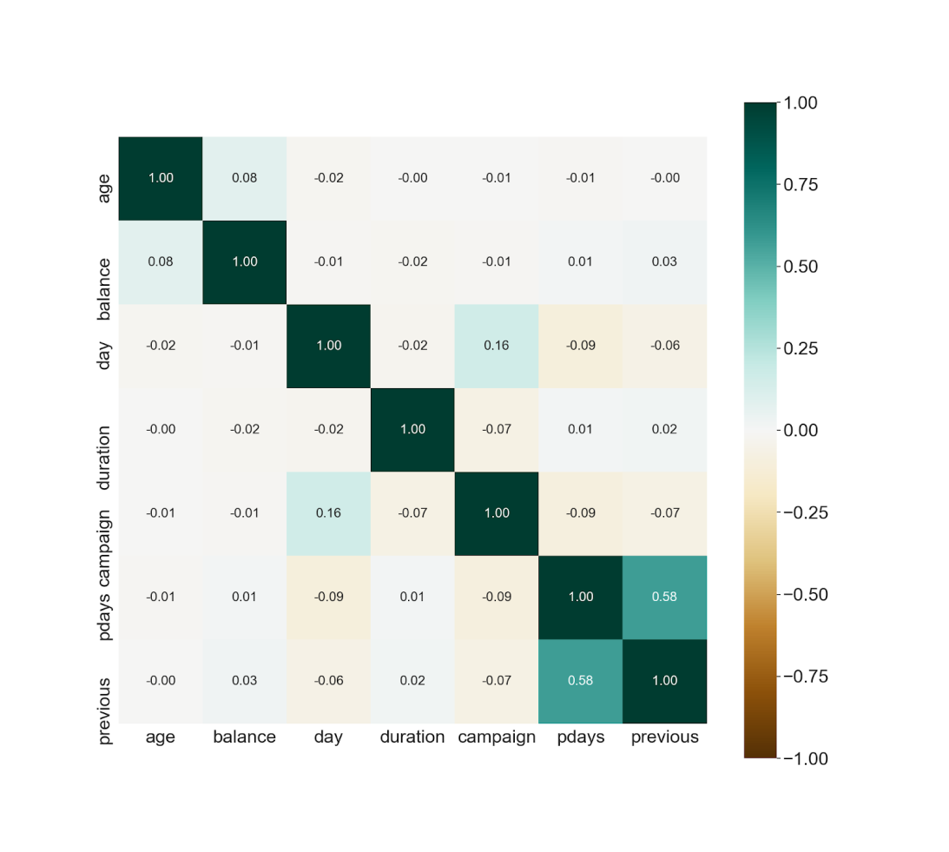
Figure 3. correlation heatmap of numerical features

  - Data preprocessing
To prepare data for the machine learning models, texts need to be converted into numbers. This is done by One Hot Encoding after combining less frequent values for the columns with high cardinality like “job” and “month”. Figure 4 shows the histograms of “job” and “month” before combining the less frequent values.
The histograms of each feature variable, shown in figure 5, were plotted using Seaborn’s “histplot” function after combing less frequent values which are lumped into “other”. In figure 5, the X-axis represents the data variable is divided into a set of discrete bins, whereas the Y-axis represents the population falling within each bin which is shown through the height of the corresponding bar. The observations within each bin are also color-coded by the outcome variable “y”, blue bars represent the clients who didn’t subscribe to a term deposit and pink bars represent the successful campaign cases. One other thing in the preprocessing step is to put all the numerical data on the same scale. Figure 6 shows the histograms of numerical columns after scaling. In figure seven, visualizing by the heatmap, no strong correlation exists between categories.

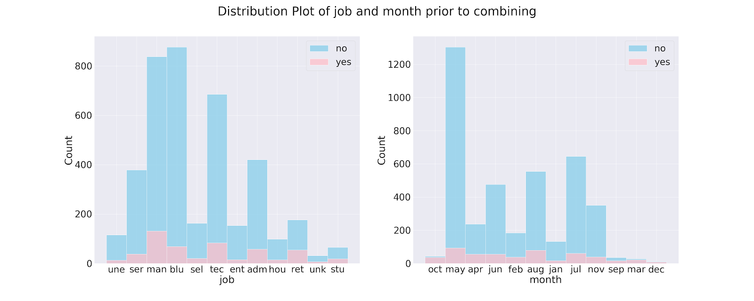
Figure 4. Distribution plot of variables “job” and “month” before combining less frequent values
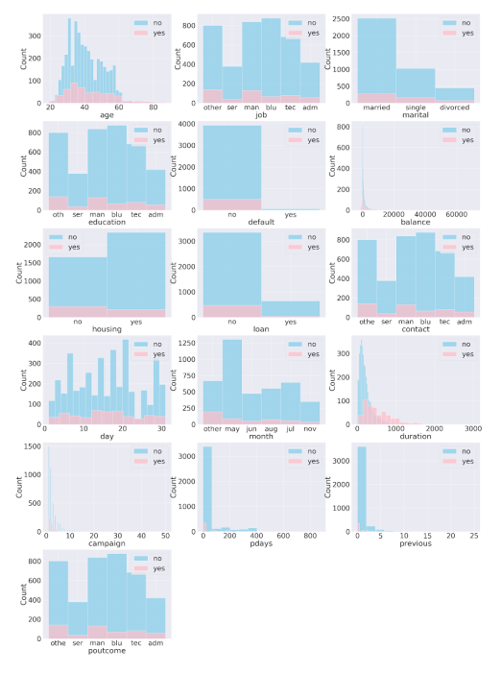
Figure 5. Distribution of each feature variable, colored by “y”
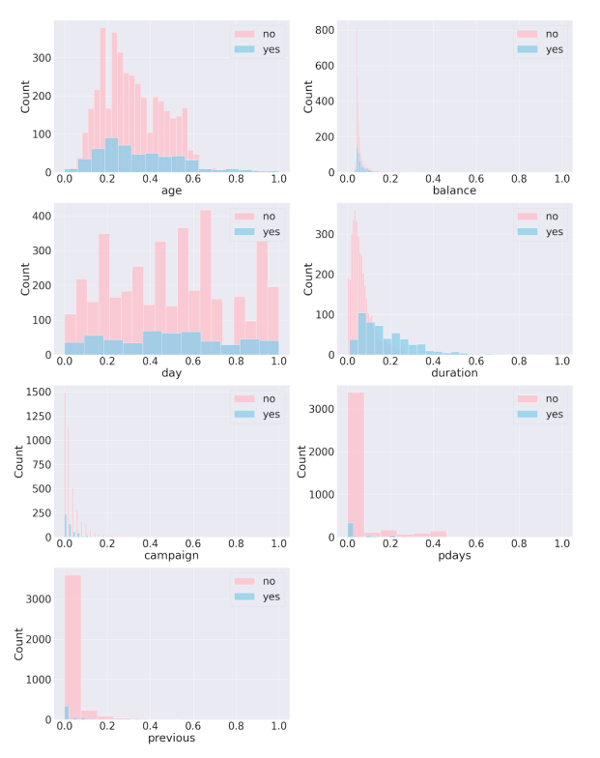
Figure 6. Distribution plot of numerical features after scaling
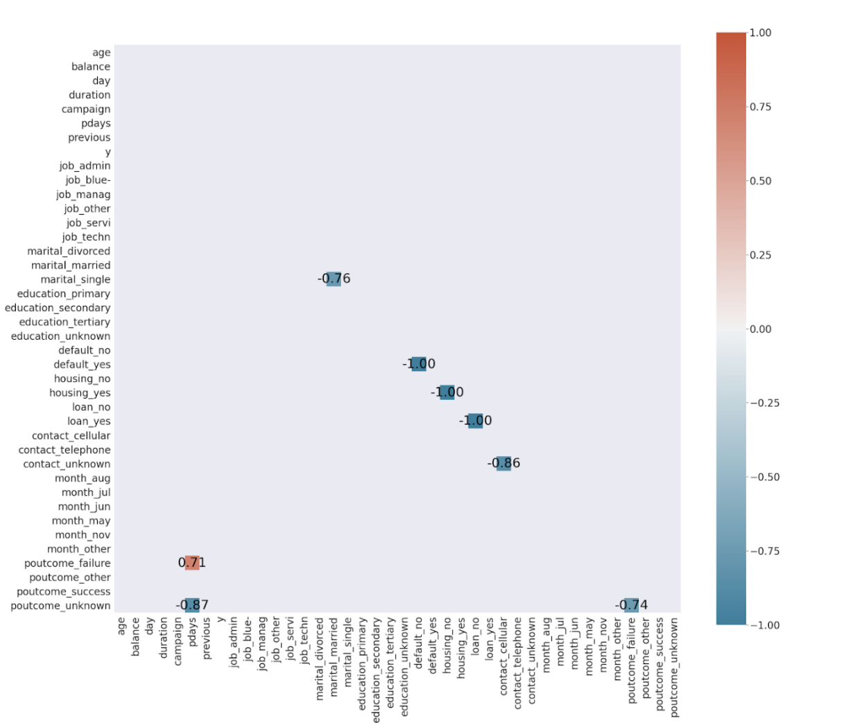
Figure 7. Correlation heatmap of all features after one-hot-encoding and scaling
  - Machine Learning Models
1) Artificial Neural Networks
The first model used was the artificial neural network model, which is a machine learning model inspired by the human brain. The model is implemented through Keras from TensorFlow 2. Multi-layer perceptron (MLP) is the most common form of neural network. A sequential model is the easiest way to build an MLP classifier. Activation function Rectified Linear Unit (ReLU) for the hidden layers and Sigmoid function for output layer were used.
After we created the sequential model, we used the Stochastic Gradient descent (SGD) optimizer and “binary cross-entropy” loss function to compile the model with accuracy as the metric. (Gandhi, 2018) The model was trained for 30 epochs, each epoch means the data is being fed through the MLP once. In figure 8, we can see a general process of how the program trained the data, giving the input and generating the output. Figure 9 here we have an illustrative graph showing the neural network. Figure 10 shows the loss and accuracy of the train and validation set during training, where it reflects that the accuracy of the program is improving. In figure 11, we get to look closer at the trend of increasing accuracy and decreasing loss during the process. It is reasonable that training accuracy is always higher than testing accuracy while training loss is always lower than the testing loss simply because testing shows what needs to be improved.
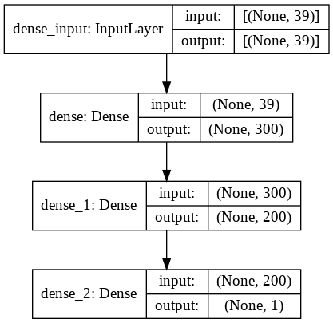
Figure 8. MLP model summary
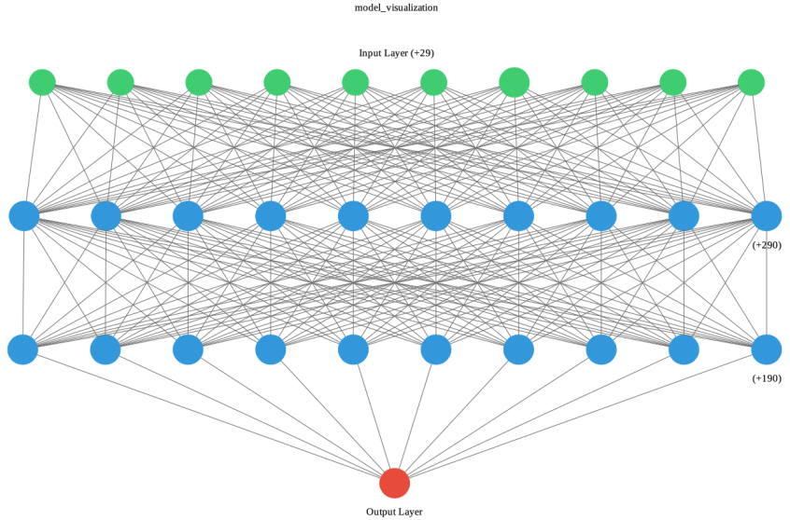
Figure 9. Artificial Neural Networks visualization

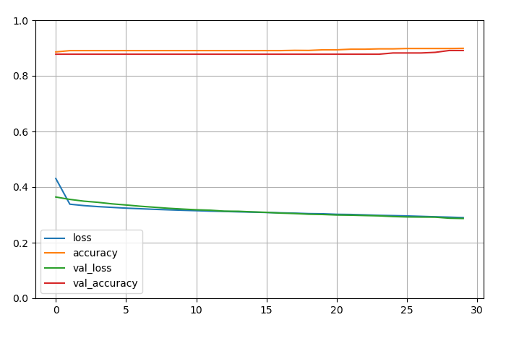
Figure 10. MLP train and validation set loss and accuracy plot during training
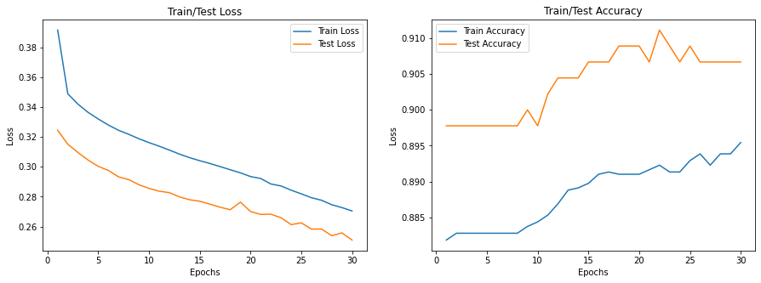
Figure 11. Train and Test set loss and accuracy of MLP
2) Logistic Regression
Regression is a type of math analysis that puts data together so that humans can analyze the trend or pattern of the relationship between variables. Logistic regression is, thereby, a machine-learning process that predicts binary information. (What Is Logistic Regression?, 2020) Logistic regression can be used to categorize different classes of information or performed as the same use as a linear regression--predicting continuous outcome. There should be a dependent/target variable and a set of independent/feature variables.
In our ROC curve (receiver operating characteristic curve) for the logistic regression model, the X-axis is the false positive rate, which means the fraction of negatives that have been selected as positive incorrectly. On the Y-axis, we have the True positive rate, which measures the fraction of the initial positives which have been predicted correctly as positive by the classifier.
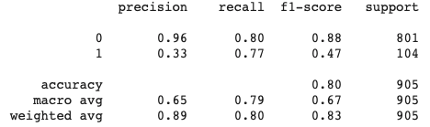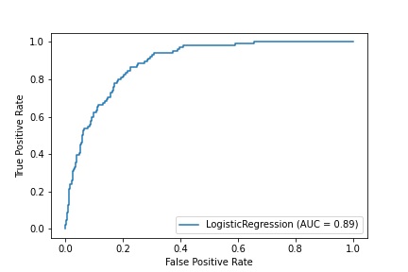
Figure 12. Logistic Regression Model classification report and ROC curve
Table 2 shows the odds ratios (converted from the log-odds which are the coefficients provided by the logistic regression classifier) of all the feature variables. The impact size of factor “balance” can be expressed by its odds ratio:
Odds subscribed/balance=x+1Odds subscribed/balance=x
When an odds ratio has a value above one, it means that the corresponding feature variable is positively associated with the target variable. For instance, in the table below, for balance we see an odds ratio of about 2.22. It means that we will see an increase of about 122 percent in purchasing term deposits when the balance of that customer’s account increased by 1.

Table 2. Odds ratios of selected feature variables
Feature Variable | Odds ratio (>= 1.5 or <= 0.5)
balance | 2.22041722
duration | 3.13496465e+05
pdays | 6.09432521
previous | 11.58689
month_other | 2.32546258
Job-related variables | Odds ratio
job_adm | 1.08849395
job_blu | 8.94624502e-01
job_man | 1.06234040
job_other | 1.02965993
job_ser | 9.70727022e-01
job_tec | 9.72869526e-01

3) Support Vector Machine

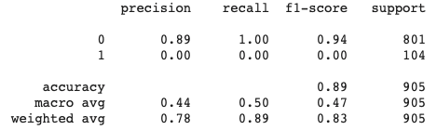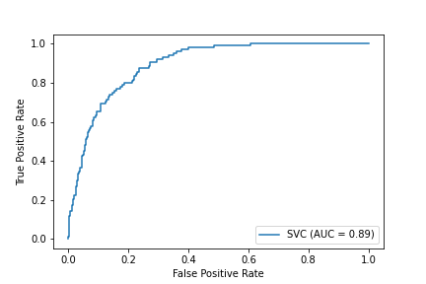
Figure 13. Support Vector Machine classification report and ROC curve

The first thing we do in an SVM is to find a hyperplane. What a hyperplane does is that it best separates the two different-class information, basically, a boundary. A hyperplane in a 3-D graph is a plane, while it is a line in a 2-D graph, as similarly, a dot in a line. Our goal is to find a hyperplane that has the largest margin between the two different classes of data. Here, we reach the support Vectors. They are the points, or positions, that are closest to the hyperplane, and serve a great role in changing the hyperplane. The AUC (Area under the curve) above represents how well the machine separates different classes.

4) Random Forest

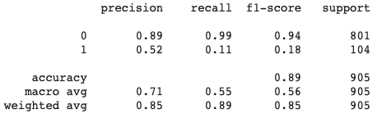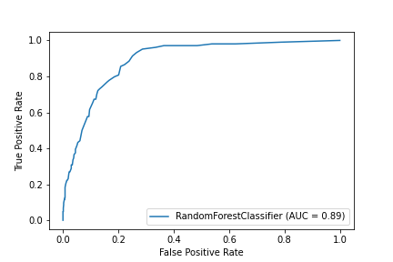
Figure 14. Random Forest Model classification report and ROC curve
The random forest is a powerful yet illustrative technique that puts relative data together. (Giraud, 2020) Each small section we see below in figure 15 is called a node. There are two kinds of nodes in general, the decision nodes and the leaf nodes. We try to split each node with a specific type of method that allows us to eliminate overfitting and eventually binning outliers and non-linear data. Decision trees help us with that. The decision tree is a model that processes the data based on the independent variables. In this case, the model will train each sample with questions such as: “What is your job?”, “What is your marital status?”. Thereby, we divide samples through different categories in each branch. Eventually, when we combine these decision trees together, we have the random forest model. One key term of this model is Gini Impurity, which is what we try to eliminate since it points to the wrong classification of nodes when splitting.
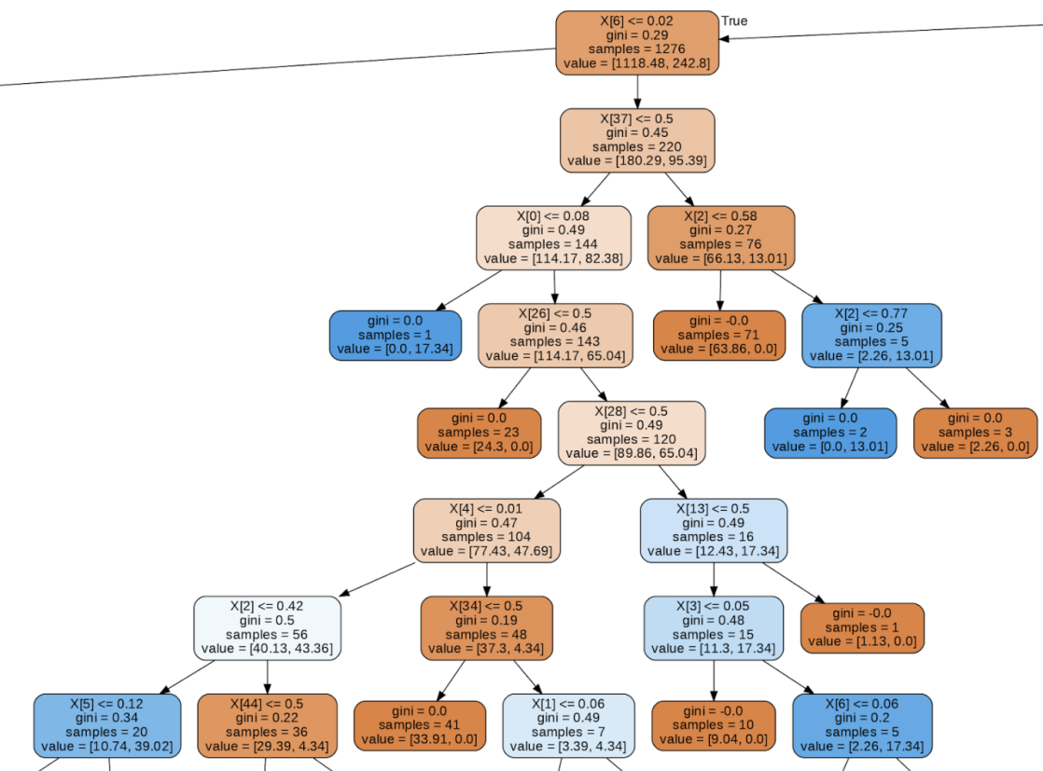
Figure 15. Part of the random forest visualization

- Results and Discussions
Upon all four models we have employed, and the previous data analysis, we found out that there is no direct relationship between what kind of jobs one has and the decision to buy term deposits as we previously hypothesized.
Data errors do exist in our data project. We can see that our source based on a bank in Portugal is a little outdated. As the old saying goes, a machine learning model can only predict what the data illustrates. We may have better predictions if we manage to get a more refined and recent dataset.

- Conclusions
For our neural network model, the curve is generally smooth, which means that the model gets more accurate at a slow but steady pace. Our process and result in logistic regression and support vector machines are quite similar. In both models, we saw a similar ROC curve, with the AUC 0.89, closer to 1 than to 0.5, which means that the models have relatively high-quality performance in distinguishing between different categories’ effect on the project as a whole. We get a high precision score in logistic regression, but with a relatively low accuracy of 0.8. On the other hand, though not that precise, Support Vector Machines proved to be more accurate. In the end, since our data is imbalanced between category 0 and 1, where category 0 has far more data and higher accuracy according to the f1 value, the macro average (calculates the unweighted mean accuracy per label or category) is far lower than the weighted average (calculates the weighted mean accuracy per label). However, both average values from the Random Forest model are higher than the other models. Therefore, random forest is one of the most successful models for this dataset.
- References
- Pettinger, T. (n.d.). Purpose of Banks. Economics Help. Retrieved from https://www.economicshelp.org/blog/glossary/banks/#:%7E:text=A%20bank%20is%20a%20financial,for%20a%20variety%20of%20loans.
- Kagan, J. (2020, December 1). Loan. Investopedia. Retrieved from https://www.investopedia.com/terms/l/loan.asp.
- What is Logistic Regression? (2020, March 10). Statistics Solutions. Retrieved from https://www.statisticssolutions.com/what-is-logistic-regression/.
- Statista. (2021, April 14). Projected annual inflation rate in the United States 2010–2026. Retrieved from https://www.statista.com/statistics/244983/projected-inflation-rate-in-the-united-states/.
- Gandhi, R. (2018, May 28). Introduction to Machine Learning Algorithms: Logistic Regression. Hacker Noon. Retrieved from https://hackernoon.com/introduction-to-machine-learning-algorithms-logistic-regression-cbdd82d81a36.
- Giraud, A. (2020, March 31). Quick intro to Random Forest - Towards Data Science. Medium. Retrieved from https://towardsdatascience.com/quick-intro-to-random-forest-3cb5006868d8.
- Narkhede, S. (2021, January 14). Understanding AUC - ROC Curve - Towards Data Science. Medium. Retrieved from https://towardsdatascience.com/understanding-auc-roc-curve-68b2303cc9c5.

______________________
Manuscript received: 19.04.2021
Manuscript received in revised form: 30 .05.2021
Manuscript accepted: 15.06.2021

